Muscle of the Week - Abdominals
This week we are looking at the abdominal muscles which are located at your belly, moving to your sides. The abdominal muscles are made up of four main muscles which support your body in many ways. This includes twisting, sitting up, having good posture, many different excises and balances. Strong abdominals can prevent many different muscle pains throughout the body and are almost always working while you are upright.
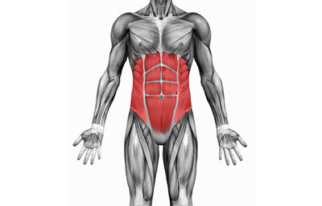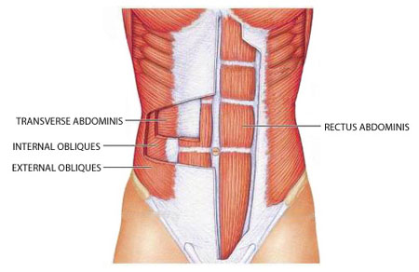

Stretching:
Abdominal stretches are generally done when recovering from specific injuries. They are not used in common stretch routines as the stretches done for abdominals may hurt your back if done improperly.

Strengthening:
There are many exercises you can do to strengthen the abdominals. The two most common exercises are crunches and planks. A crunch, also known as a sit up, is done with your back on the ground, legs slightly bent, and hands behind your head or reaching towards your knees. Without pulling your head forward, lift your back off the ground and maintain your feet on the ground. This may be difficult! A plank is done by holding a push up position, or holding the same flat position on your elbows for a certain amount of time. Although not completely necessary to do these strengthen exercises, it is important to maintain an active lifestyle for your abdominals to stay strong!
